Sprint-3

**Application Building**

RUN THE APP

|  |  |
| --- | --- |
| TeamID | LTVIP2023TMID07965 |
| ProjectName | Classification of Arrhythmia by Using Deep Learning with 2-D ECG Spectral Image Representation |

TASK:

***Run The App.***

RUN ON LOCAL HOST (SCREEN SHOT):

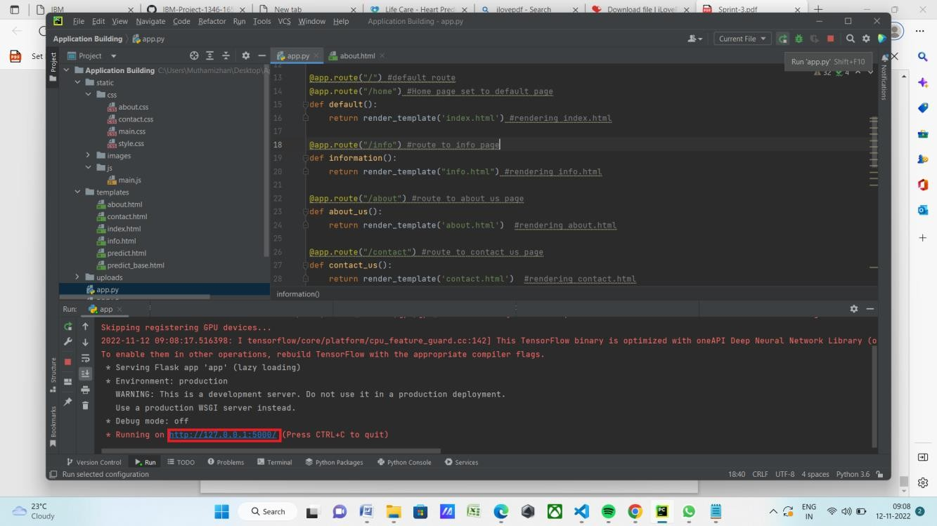

LOCAL HOST:

CLICK PREDICT (SCREEN SHOT):

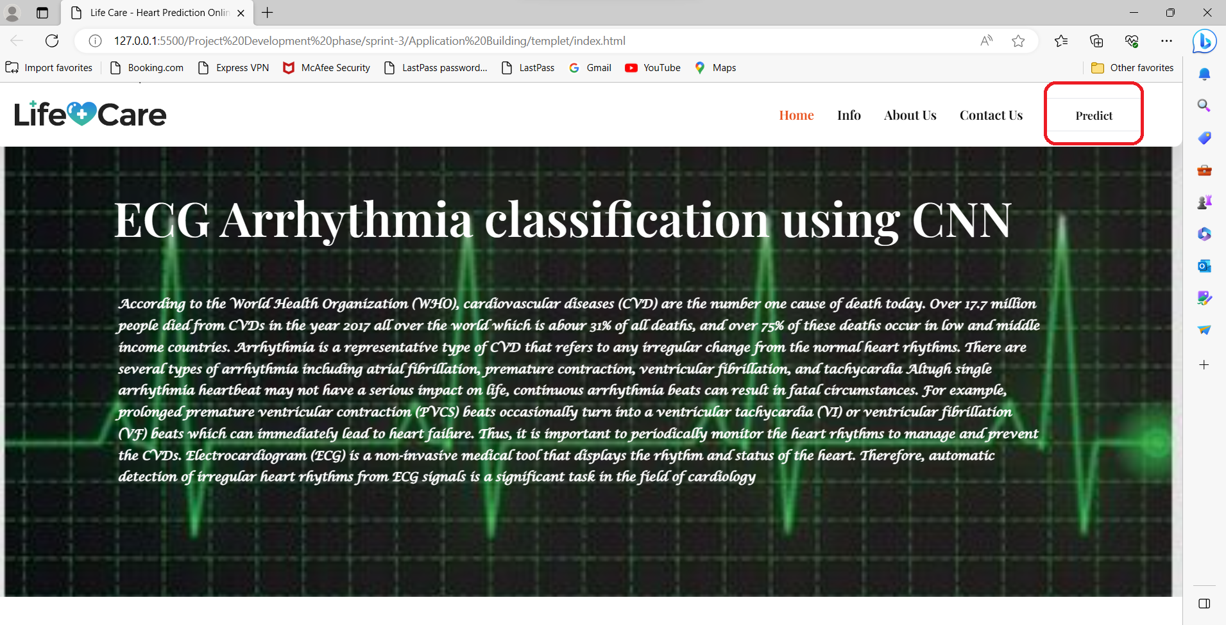

CLICK CHOOSE BUTTON (SCREEN SHOT):

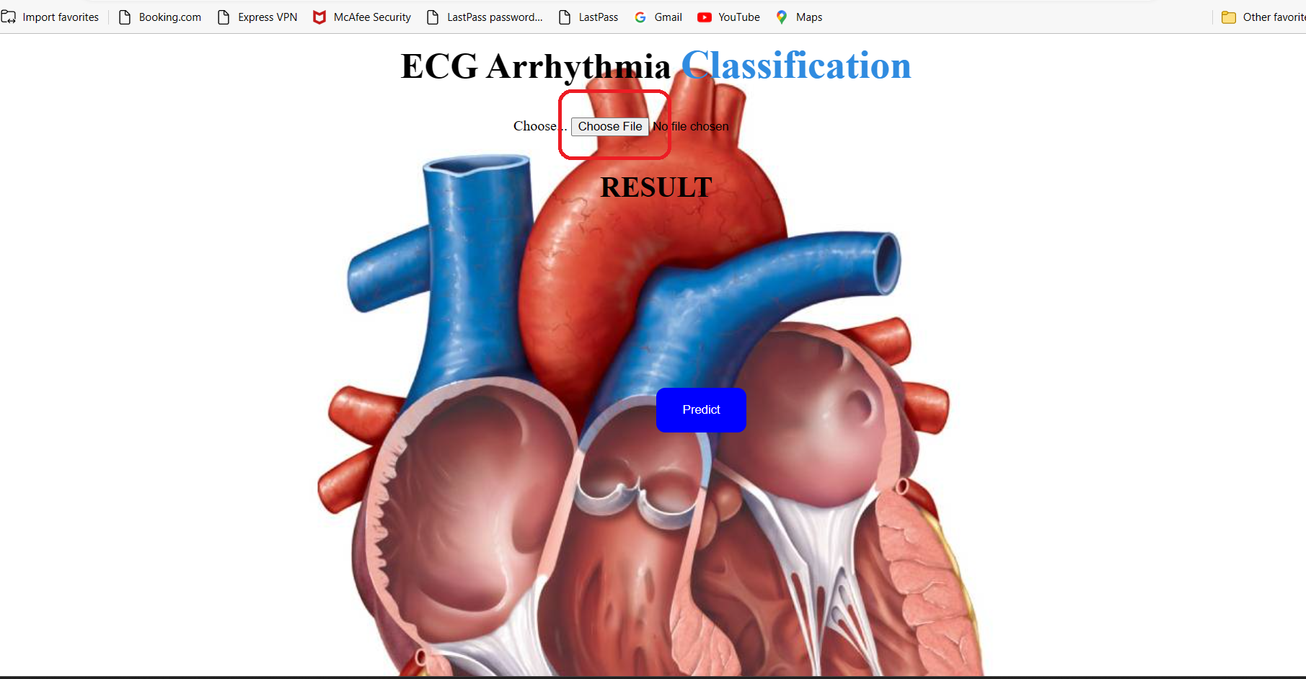

GO TO UNKNOWN FILE (SCREEN SHOT):

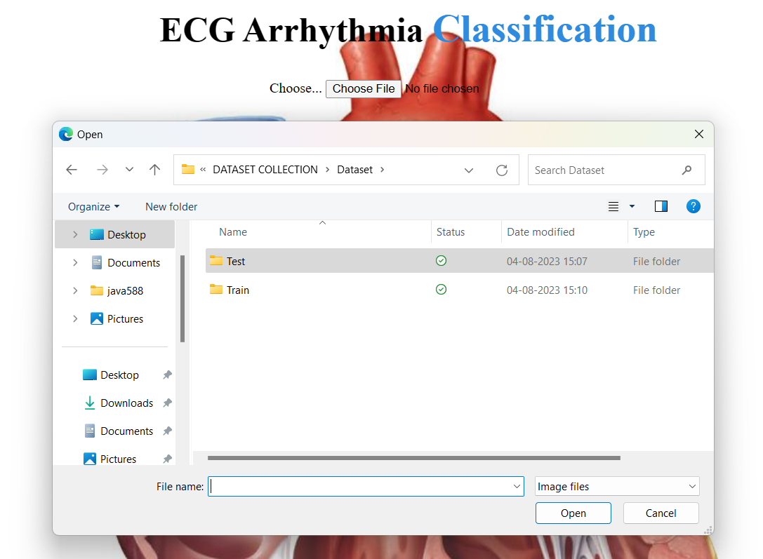

SELECT ANY FILE (SCREEN SHOT):

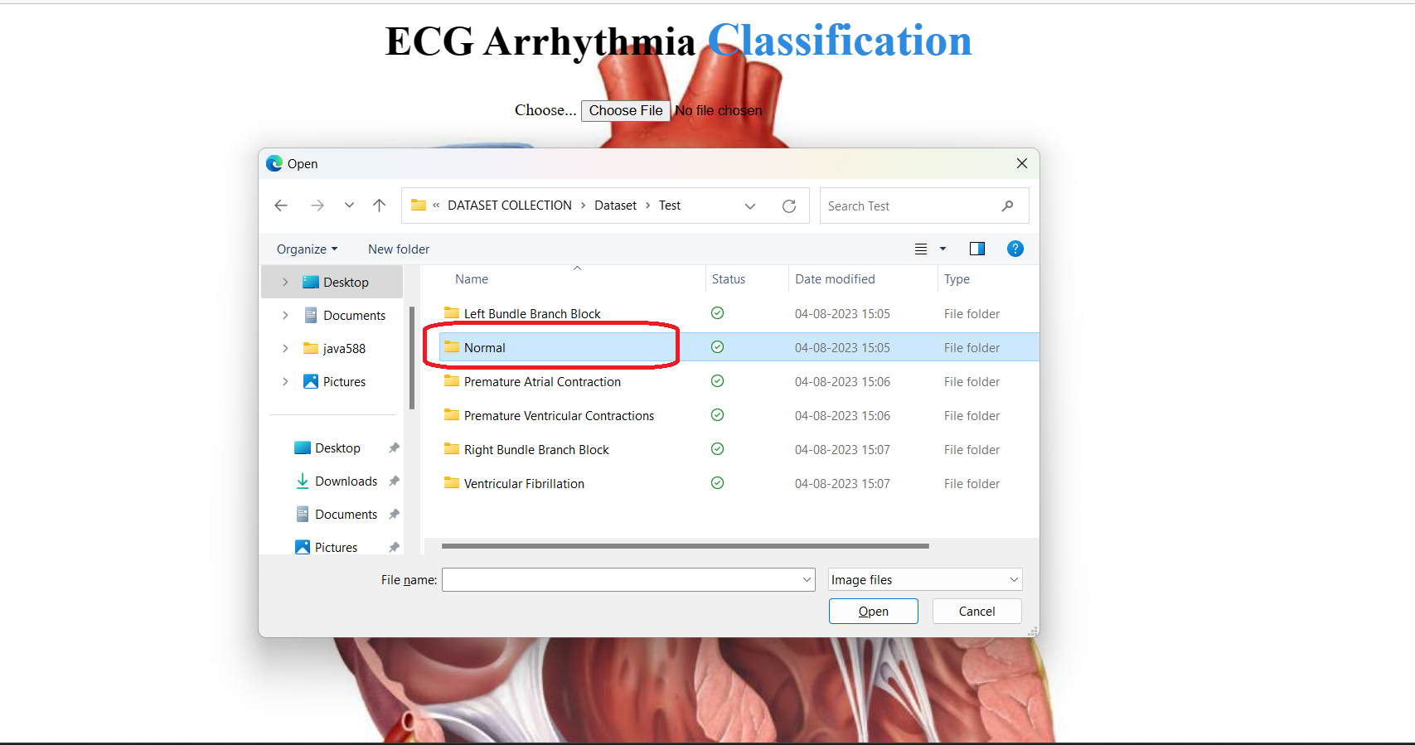

CLICK ANY ECG PHOTO (SCREEN SHOT):

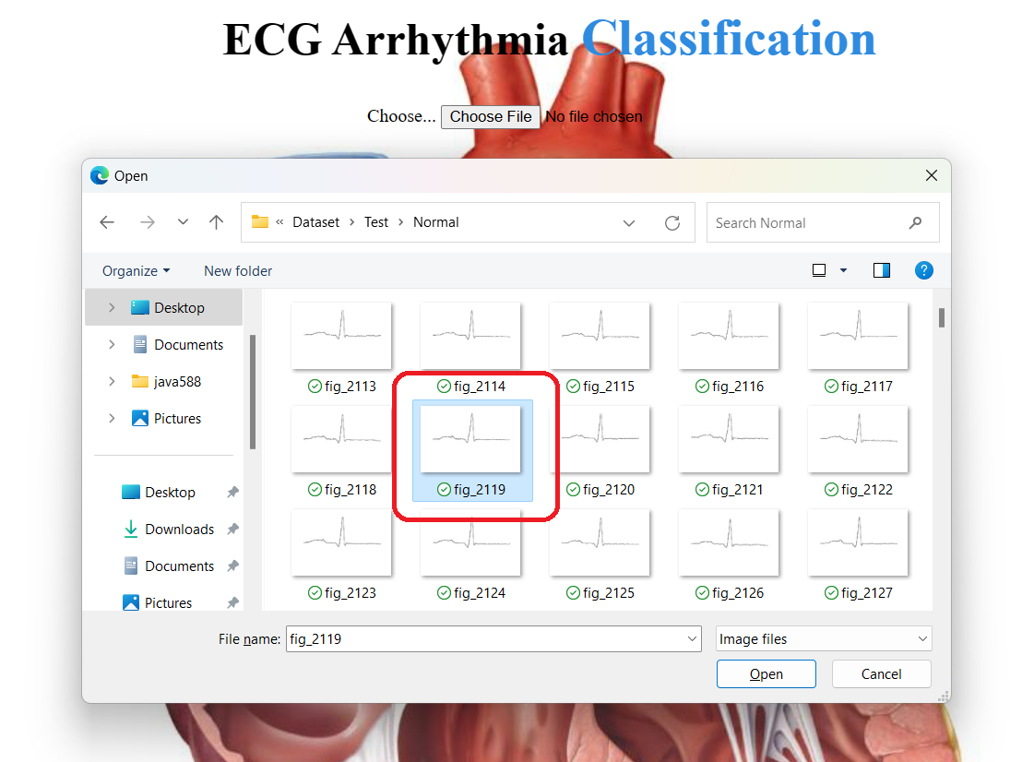

CLICK PREDICT BUTTON (SCREEN SHOT):

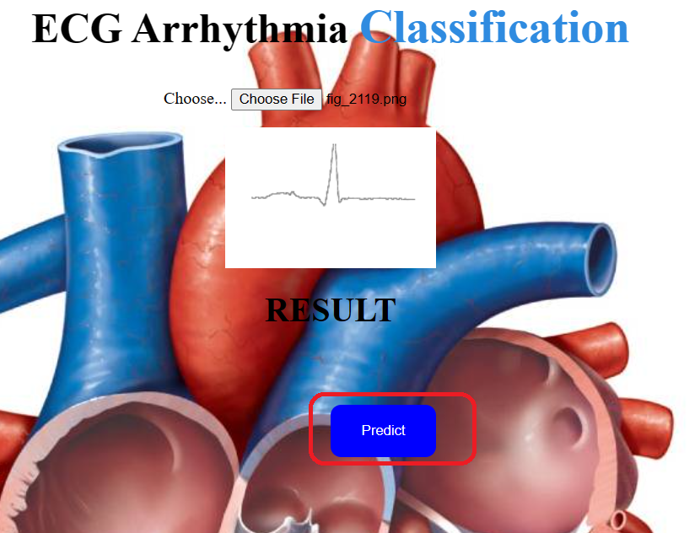

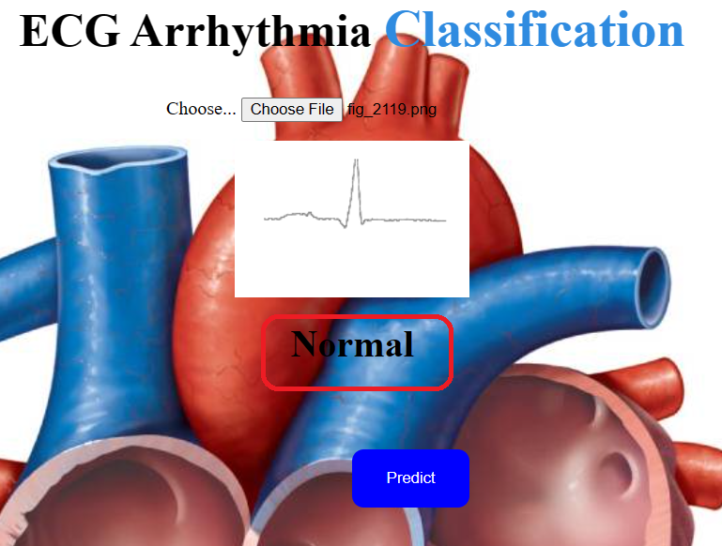SHOW ON RESULT (SCREEN SHOT):

PREDICT THE CORRECT RESULT